**SAT Date Checker**

Welcome to SATDateChecker! This program will show __(#) results of the closest SAT Test Centers which have available seats based on the SAT Test Date.

* Please enter a ZIP code -> Please enter your ZIP code
* Available Dates -> Available SAT Dates for ZIP code ______
* Enter a Date-> The available test dates are numbered above. Please enter the number of the SAT date of interest
* There should be an option where you can show each school and see what dates one school has available. It might take a bit of time to make, but you can finish it after we have finished the applications.
* The addresses of the locations should be shown, or link to Google Maps so users can quickly check how far they are from the school

**About**

SATChecker is an application run through a Windows or Mac operating system to quickly check for available seats in surrounding testing centers on satsuite.collegeboard.org without logging into the College Board account. Reservations will need to be made separately after logging into your collegeboard account at satsuite.collegeboard.org.

**The main purpose of this Python script is to:**1- Open SAT Checker program  
2- Provide instructions for user to input ZIP code.   
3- Have user select SAT test date of interest among a list of available SAT test dates.

4- List SAT Test Center locations within a 25 mile radius from the zipcode provided.

​5.1- If yes, prints the found locations and email them to email(s) of choice.  
​5.2- If no, it will keep scanning for test centers until a seat opens

**Installation:**

In whatever operating system you are using, Open Command Prompt and navigate to the folder which has the code.

- In Windows you can hold SHIFT+Right mouse click then select “Open Powershell here”

| pip install -r requirements.txt |
| --- |

Edit the code, Section called “Mailing Details” and add your mailing details

- Open main.py in any file editor/IDE of your choice, I used Notepad++, you can use VS Code or just plain NotePad

- Feel free to change subject, add more receivers for the email if need be.

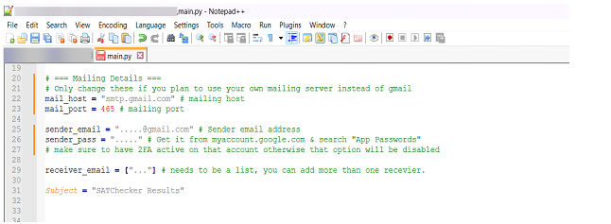

**Running:**

In whatever operating system you are using, Open Command Prompt and navigate to the folder which has the code.

- In Windows you can hold SHIFT+Right mouse click then select “Open Powershell here”

Run the following command

| python main.py |
| --- |

In some systems, the command for using Python could be “Python3” in that case, the command would be

| python3 main.py |
| --- |

1- You will be prompted to enter a ZIP Code.

2- The script will run a browser which opens the site and inputs your zip code looking for available dates.

3- You will be prompted to select a Date.

4- The script will now view available locations for said Date.

If there are available locations, the script will print them and email them to the receiver's list of emails. If there isn't any locations it will keep scanning until a seat opens up.

**Runtime Example:**

